Tourism

The countryside of the part of Podrinje involving certain areas of Loznia municipality (84.000citizens), along with Jadar, Western Serbia area of historical significance, is versatile and picturesque. The plains, valleys, hillside and mountain side relief of the Loznica municipality, interchange and interact in a specific way, making this area recognizable and appealing to tourists.

Along with versatile countryside, of harmonious relief forms, fertile land, natural and anthropogenic values, stimulating and sedative climate, small rivers and streams, stormy historic past should be pinpointed as well. It is recognizable by people and events and monuments and manifestations dedicated to them, it enhances image of the Loznica municipality on domestic tourist market.

Following places are more distinguished that other tourist destinations in the Loznica municipality and its vicinity.

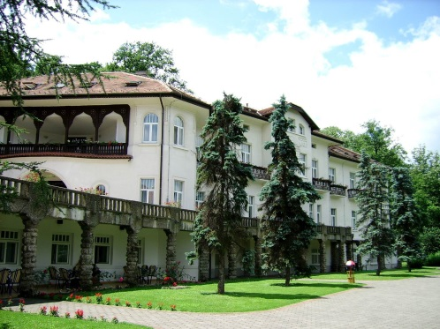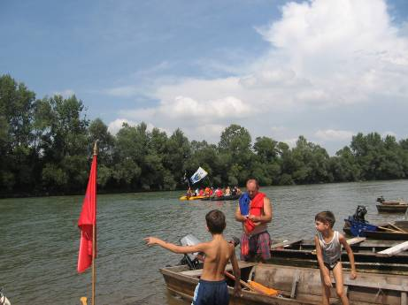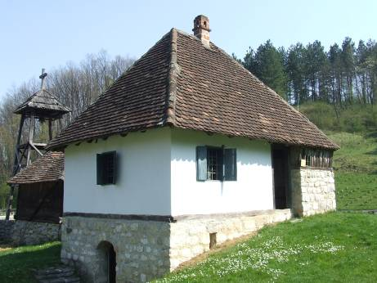

SPA – Banja Koviljača and Banja Badanja
RIVER DRINA
MOUNTAINS –Gučevo i Cer
ETHNO VILLAGE TRŠIĆ
MONASTERIES – Tronoša, Čokešina
ARCHAEOLOGICAL LOCALITIES – Paulje, kod Brezjaka
REMAINS OF OLD TOWNS AND FORTRESSES – Vidojevica, The town of Kosana, The town of Trojan, The Town of Koviljka (Gradac)
CULTURAL MONUMENTS – Monument of First Serbian Uprising in Cokesina, Monument to fallen victims in Draginac, etc.
CHARNEL HOUSE FROM I WORLD WAR – on the mountains of Gučevo and Cer
MUSEUMS – Regional Museum of Jadar in Loznica, museum exhibitions in: Tršić: Museum of Vuk’s festivals and Vuk’s birth house with farmstead, the Museum of Dositej, etc.
GALLERY – Art Gallery – legacy of Mico Popovic and Vera Bozickovic Popovic in Loznica
CULTURAL –TOURIST EVENTS – The Days of Vukov sabor, Đački Vukov sabor, The Days of Mico, The Days of Cvijic, International folk festival »Europe dances«, The Days of October, commemoration of the battles in Cer and Gucevo
MONUMENTS TO IMPORTANT PERSON – Vuk Karadžić, Jovan Cvijić, Filip Višnjić, Stepa Stepanović
OLD BUILDING – Elementary building »Anta Bogićević«, old Grammar school »Vuk Karadžić«, the house of the Katic family – gallery Miće Popovića, Muzej Jadra, Vukov dom kulture i dr.; old villas in Banji Koviljači: Bosna, Koviljača, Podrinje, Gučevo, Stražilovo etc., sulphurous bath »King Peter the First«, spa restaurant»Kur-salon« etc.

Hotel capacities

Table 110. Hotel capacities, 2007
Destination | Number of hotels/resorts | Number of beds
Loznica | 1 | 50
Banja Koviljača | 2 | 400
Banja Badanja | 1 | 25
Gučevo | 2 | 410
Tršić | 2 | 32
Drina- Sunčana reka | 1 | 90
Drina MN | 1 | 18

10.3 THE STRUCTURE OF HOTEL CAPACITIES IN THE LOZNICA MUNICIPALITY

RESORT „PODRINjE“ – Banja Koviljača (160 beds + 80 auxiliary  1/1 – 4 rooms  1/2 – 65 rooms  1/3 – 4 rooms  A – 7 | 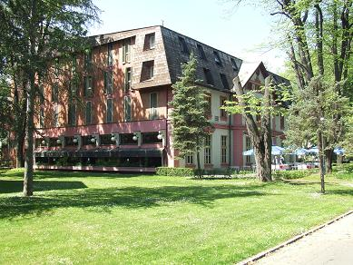

SPECIAL HOSPITAL - Banja Koviljača (Villa Hercegovina, Villa Dalmacija , Novi zavod and hotel Standard ( 550 beds ) | 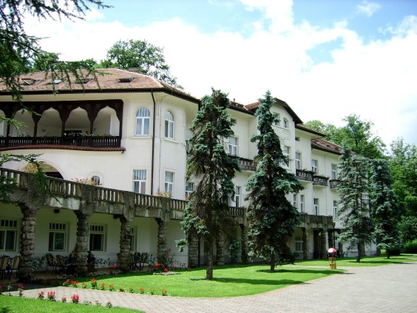

ROYAL SPA HOTEL – Banja Koviljača
ROYAL SPA Hotel is situated in the centre of Banja Koviljaca, at the entrance to the one of the most beautiful spa parks in Serbia. It has become an ideal place for resting – a real oasis of peace, stillness and luxury.
Owing to its perfect location, modern elegance and diverse offer, this hotel represents a perfect choice for all guests who need a break from everyday stress, peace and quietness, relaxation and family gathering, walking and picnic in nature, celebrations, organized conferences, seminars, or relaxation in our wellness center - Spa treatments, massages and fitness.
Telefon: +381 (0)15 818 010

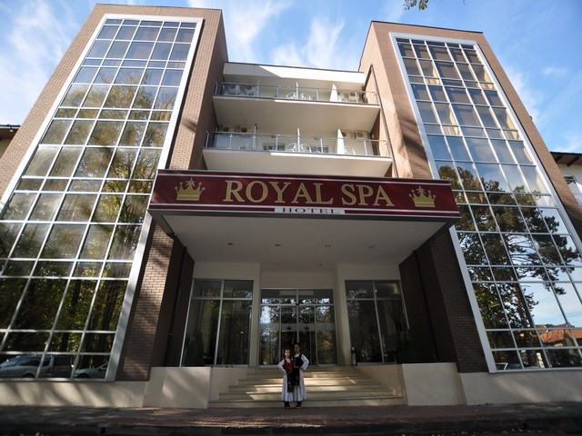

RESORTS „VIDIKOVAC“ – Gučevo (59 bed)  1/2 - 2  1/3 – 4  1/4 – 4  1/5 – 3  1/6/- 2 | 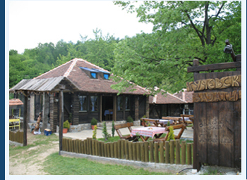

RESORT “ GUČEVO ESTER“ – Gučevo (130 beds)  1/2 , 1/3 , 1/4 rooms with bathrooms | 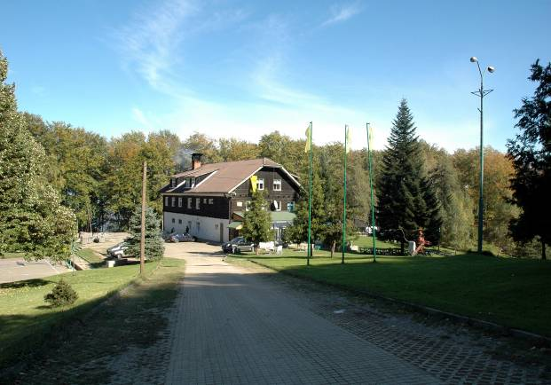

PLAVI RESTORAN – Loznica (50 beds)  1/1 - 3  1/2 – 20  A – 4 | 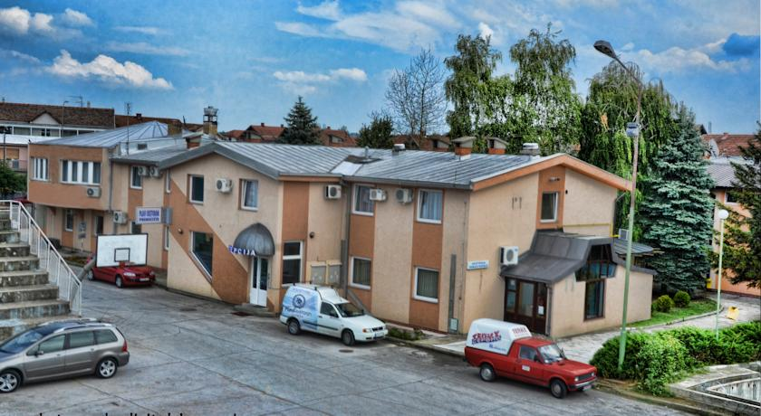

SRC „SUNČANA REKA“ – Gornja Koviljača (90 beds)  Guest houses with double rooms with bathroom  The unique ambience of the complex offers : houses for accommodation of guests ( 90 beds ), village “K’o nekad” (10 beds)restaurant ( 270 seats ), summer terrace (700 seats), sports grounds for football and, volleyball, tennis ... , an amusement park for children , business hall ( 100 seats) , the exhibition "Drina through the centuries", paddock for horses and other activities (boating, horseback riding, carriage rides, " Šotrina beach", driving blocks, excursions , hiking ... )  The complex is a church dedicated to the Visitation of the Virgin was built in 2013.  Telefon: +381(0)15822-250 www.suncanareka.rs  Restaurant “Plava ribica” and Villas “Nešić” – Drina, Loznica  In the complex there are tennis courts, large and small football , volleyball on the sand, playground for children, an artificial lake , swimming is the Drina River , walking ...  The restaurant has two halls - a large ( 500 seats ) and small ( 50 seats ) . Villa " Nesic " has 4 rooms (12 beds) and 2 apartments (6 beds ) equipped according to all European standards.  Telefon: +381(0)15879-882 www.mn.co.rs | 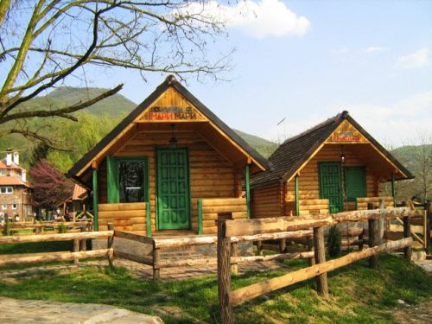  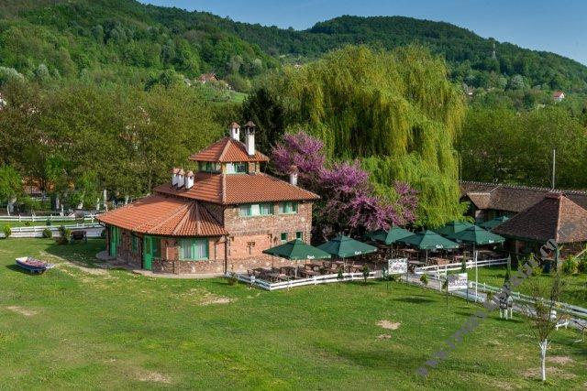  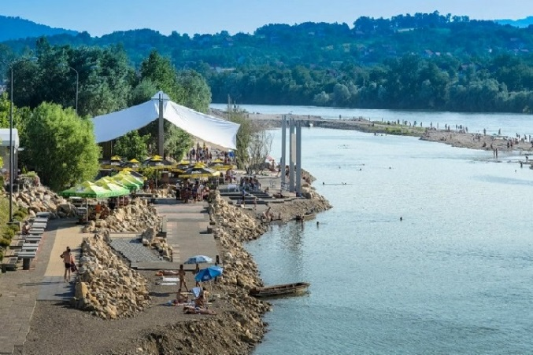

INN „MIŠIĆ“ – Tršić (25 beds) | 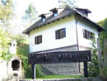

INN „MILICA“ – Tršić (7 beds) | 